**Installation on Docker:**

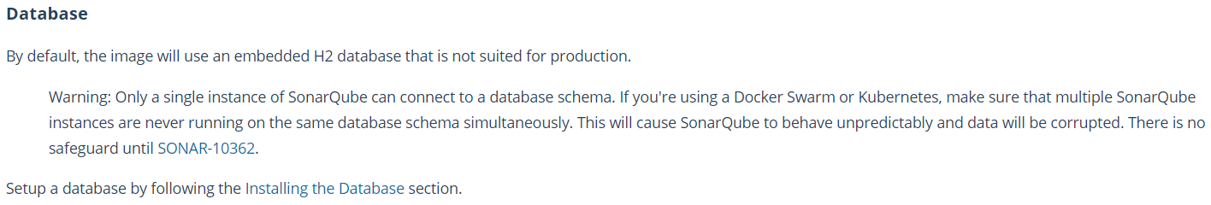

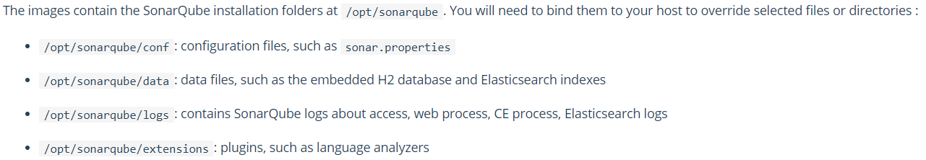

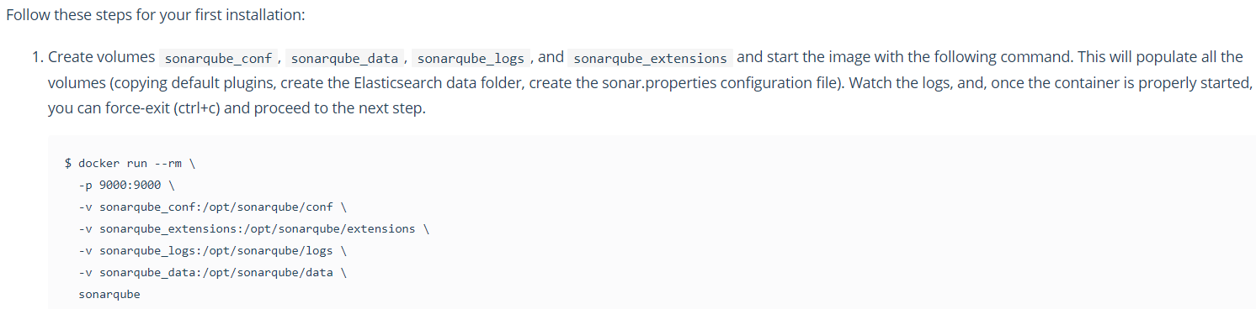

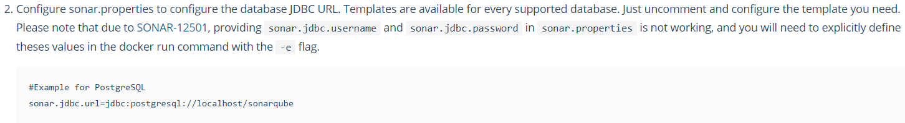

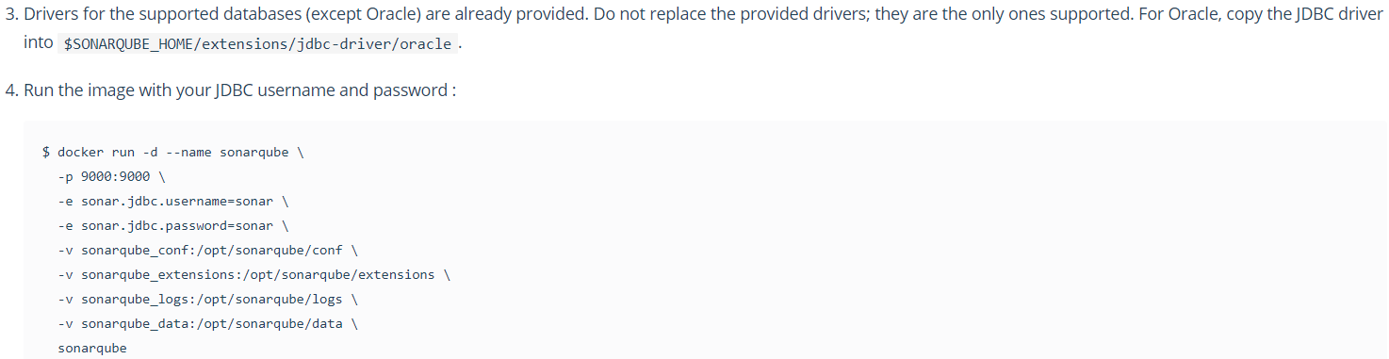

**Installation on Kubernetes:**

We need to install DB first, then we need to create PVC for “/opt/sonarqube/data” and “/opt/sonarqube/extensions” directories as we need this data even when we restart the POD

Create PVCs as below yaml files





After creating PVC, we need a secret file to store the DB details as below



Now we can create a deployment with below yaml file by updating the sonar properties and volume mounts



We need to pass the below strings in yaml file to get the sonar user access to PVC mount paths inside the container. As PVC by default gets mounted with root user. So, this arguments are must. Without this sonar user can’t access volume mounts and the pod will get failed

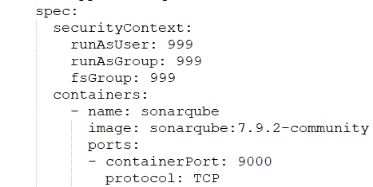

And finally, we create service for the pod as below



One this is all done, we can access the sonar dashboard with service IP

**Another example yaml files:**





